# ASK

Key task: Use smart devices data to analyze how people are using smart devices to monitor their activity . Use this information and give recommendations on how Sršen can improve their marketing strategy.

https://rstudio-pubs-static.s3.amazonaws.com/834490_81cc375d5cdd451da7c7428872d0d05f.html

## STAKEHOLDERS.

Urška Sršen: Bellabeat’s cofounder and Chief Creative Officer

Sando Mur: Mathematician and Bellabeat’s cofounder; key member of the Bellabeat’s executive team

Bellabeat marketing analytics team: A team of data analysts responsible for collecting, analyzing, and reporting data that helps guide Bellabeat’s marketing strategy.

## DELIVERABLE (CLEAR STATEMENT).

The main task would be to identify the usage of lifestyle smart devices by users. To do that we will need to collect data from users who are using smart devices to monitor their health. These devices should be for the users who are not using Bellabeat device. This will influence the marketing strategies that Bellabeat users use to advertise.

# PREPARE

This Kaggle data set contains personal fitness tracker from thirty fitbit users. Thirty eligible Fitbit users consented to the submission of personal tracker data, including minute-level output for physical activity, heart rate, and sleep monitoring. It includes information about daily activity, steps, and heart rate that can be used to explore users’ habits. The CCO has notified that there might be some problem with this data and to consider another data to help address those limitations.

## Where is the data stored?

The data is stored as part of the Fitbit Business tracker data set made available through mobius.

The data is stored in CSV files. Data is organized in terms of minute, hourly and daily measurements of calories intake, steps, sleep and activity intensity. Good data is ROCCC(Reliable, Original, Comprehensive, Current, Cited).

The dataset is reliable. It contains fitness data about sleeps, calories taken in, heart rate and steps taken

The dataset is original. The data was collected by original users.

The data was comprehensive enough for use.

The data is not cited but it is available in Kaggle.

## ****How are you addressing licensing, privacy, security, and accessibility?****

The data was classified using a unique ID.

## How did you verify the data’s integrity?

The data has integrity since it is on Kaggle. Kaggle checks if it’s data has integrity before putting it in the platform. The unique id is consistent throughout in all the datasets.

## ****How does it help you answer your question?****

The data will help identify trends in the use of Fitbit trackers.

## ****Are there any problems with the data?****

The date columns are stored as strings. I will have to convert them to date.

# PROCESS

# STEPS TO ENSURE DATA IS CLEAN

Remove rows that have null columns

Ensure the datetime columns are properly formatted.

Remove duplicate rows based on user ID

# ANALYZE

* How should you organize your data to perform analysis on it?

I merged the daily activity data and daily sleep data. Performed a full join and replaced all na values with 0.I used accurate 33 users.

* Has your data been properly formatted?

The date was converted to the appropriate consistent format.

* What surprises did you discover in the data?

There was a negative relationship between the total steps taken and sedentary minutes.

* What trends or relationships did you find in the data?

Sedentary minutes are not related to calories burned. Increase in steps and distance reduces calories.

* How will these insights help answer your business questions?

This shows which group of consumers poorly use the app.

# SHARE

According to the calories burned graph. There is a positive correlation between calories burned and steps taken. More calories are burned between 1 step and 15000 steps. There is some problem with the data: For example >35000 steps and less than 3000 calories burned. This is caused by errors in data collecting.

According to the diagram of calories burned per hour logged: number of hours logged in does not translate to calories burned.

The errors are:0 hours logged in translating to zero calories burned.

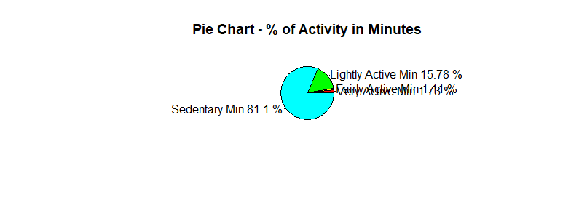

According to the above diagram:

Sedentary minutes takes the greatest percentage which is 81.1%

This means users are using this app to log details about their inactive and passive moments

The app is rarely used to track fitness.

This is discouraging since this app was developed to encourage fitness.

# ACT

# RECOMMENDATIONS

Trends in smart device usage

Majority of the users use the app to record data on the weekdays when they are barely exercising.It seems the users spend a lot of time during the weekend.Users also barely record their sleep data.

Bellabeat app could be used to encourage women to exercise and practice healthy living. They could use sample data to show women how they would improve Healthwise if they used the app.

The marketing strategy based on the trend:

Bellabeat app could be used for creating awareness. The organization can help women understand the importance of working out and healthy living and how this app would assist them. The app could also have notifications thereby reminding customers when to work out and the improvement on their health and increase their life expectancy.